Detector-Plane Imaging (DPI):

An Instrumentation-Grounded Measurement-Plane Framework

Abstract
Detector-Plane Imaging (DPI) provides an instrumentation-grounded, detector-plane model of quantum observation, establishing that interference is encoded in a pre-detection coherence imprint and that detector-plane processing determines whether this structure is preserved or irreversibly lost. The QMCTB-01 benchmark is defined as a theoretical detector-plane causality test using a near-field double-slit configuration with identical excitation and propagation, evaluated under two detector regimes: intensity-only and correlation-preserving sensing.
By introducing fringe visibility (V) as a measurable criterion, DPI establishes a falsifiable distinction between detector architectures: intensity-only detection yields no stable interference (V ≈ 0), while correlation-preserving detection yields high-contrast interference (V ≈ 1). This framework treats quantum measurement as a hardware-defined selection process governed by coherence preservation at the sensor layer.

1. Introduction
Quantum interference experiments are traditionally interpreted through wave–particle duality, leading to ambiguity regarding when and how interference arises. Detector-Plane Imaging resolves this ambiguity by separating:
- Pre-detection coherence (imprint domain): a continuous, phase-encoded field structure
- Post-detection measurement outcome: a discretized, detector-dependent representation
Within this framework, particles remain primary excitations of quantum fields, while wave-like behavior emerges as a contextual imprint of propagation. Measurement does not create interference; it determines whether pre-existing coherence becomes observable.

2. Causality: Quantum Measurement Stack (QMS)
Field excitation → Imprint propagation → Detector plane → Readout → Analysis
The detector plane defines the measurement boundary where:
- Phase and correlation information may be preserved or discarded
- Information loss becomes irreversible
Once correlations are discarded at this stage, they cannot be recovered by downstream processing.
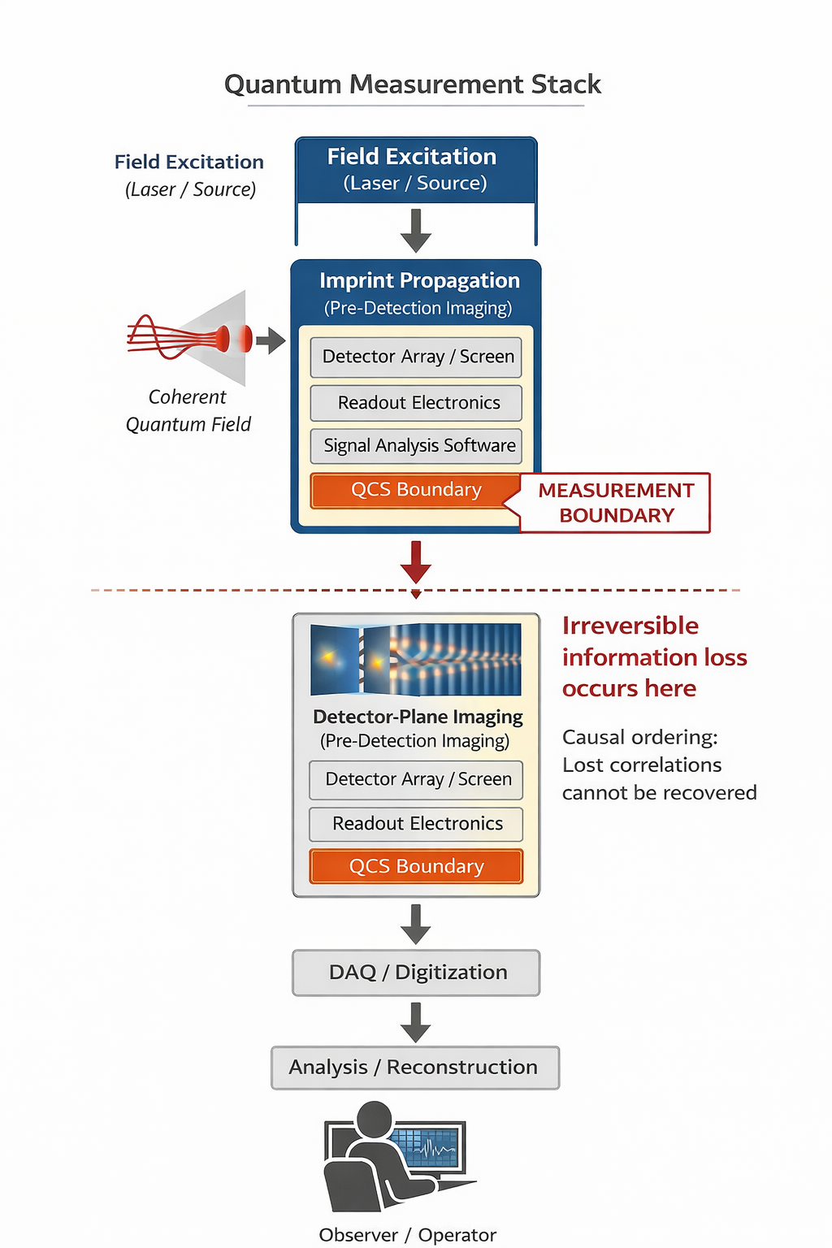

3. Mechanism: Detector-Plane Selection (DPI)
A single coherence imprint arrives at the detector as a continuous, phase-encoded structure. The detector determines whether the encoded correlations are preserved.

Intensity-Only Detection
- Measures local intensity only
- Discards phase correlations
- Output: No stable interference (V ≈ 0)

Correlation-Preserving Detection
- Retains phase relationships across the detector plane
- Preserves coherence structure
- Output: High-contrast interference (V ≈ 1)

This behavior is consistent with Glauber’s coherence theory, where interference visibility depends on preserved field correlations rather than intensity alone.

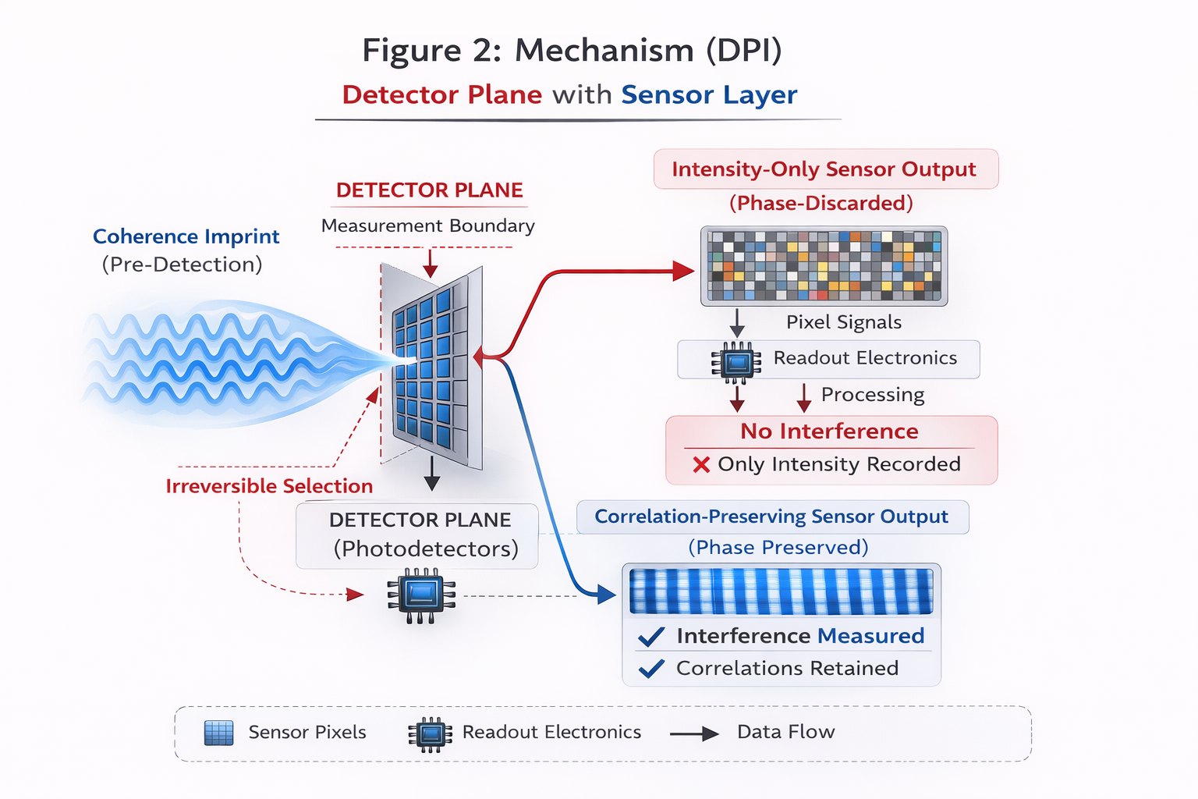

4. Validation: QMCTB-01 Benchmark
Identical excitation, propagation, and photon statistics are maintained. Only detector architecture changes.
Predicted results:
- Intensity-only detection → no interference (V ≈ 0)
- Correlation-preserving detection → stable interference (V ≈ 0.8–1.0)

Same input → different detector → different observed reality.
Physical instantiation: A near-field double-slit setup with two detector types: (i) intensity-only pixel array, (ii) wavefront-sensitive sensor array preserving inter-pixel phase relationships.
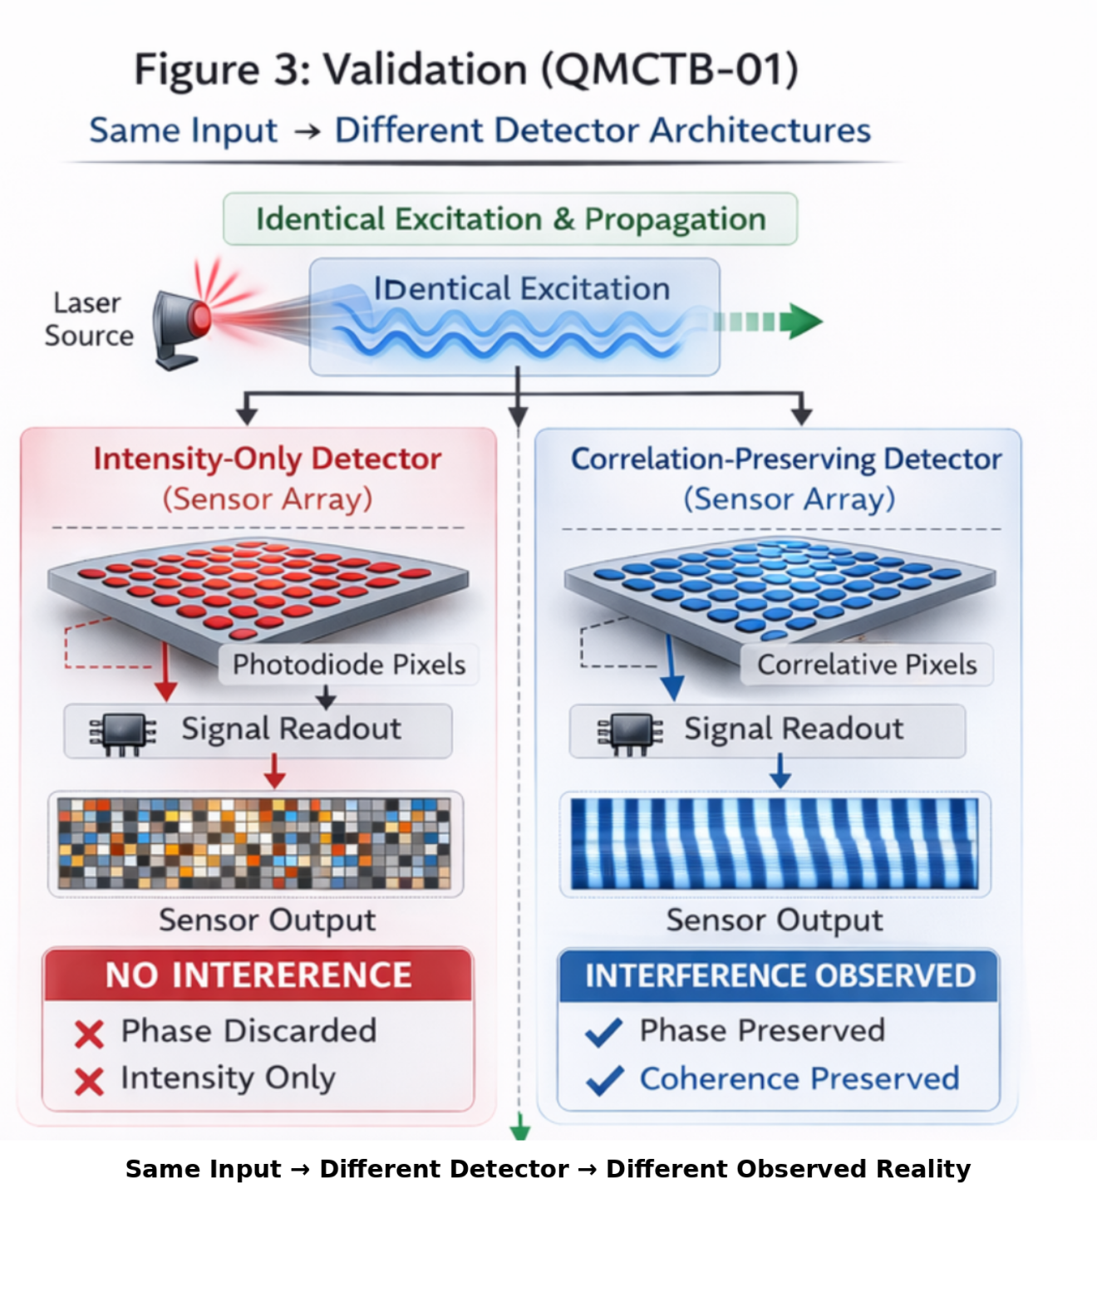

5. Key Insight
Interference is encoded prior to detection; the detector determines its observability.

6. Conclusion
Detector-Plane Imaging establishes measurement as a detector-defined process operating at the instrumentation layer, where quantum and classical optics converge at the sensor plane. Measurement outcomes are determined by coherence preservation, not photon accumulation.
Same input → different detector → different observed reality.

References
[1] Eisaman, M. D., Fan, J., Migdall, A., & Polyakov, S. V. Single-photon sources and detectors. Review of Scientific Instruments 82, 071101 (2011).
[2] Hadfield, R. H. Single-photon detectors for optical quantum information applications. Nature Photonics 3, 696–705 (2009).
[3] Janesick, J. R. Scientific Charge-Coupled Devices. SPIE Press (2001).
[4] Rogalski, A. Infrared detectors: status and trends. Progress in Quantum Electronics 27, 59–210 (2003).
[5] Glauber, R. J. The quantum theory of optical coherence. Physical Review 130, 2529–2539 (1963).
[6] Tonomura, A. et al. Demonstration of single-electron buildup of an interference pattern. American Journal of Physics 57, 117–120 (1989).
[7] Bach, R., Pope, D., Liou, S. H., & Batelaan, H. Controlled double-slit electron diffraction. New Journal of Physics 15, 033018 (2013).
[8] Lemos, G. B. et al. Quantum imaging with undetected photons. Nature 512, 409–412 (2014).
[9] Qian, G. et al. Quantum induced coherence light detection and ranging. Physical Review Letters 131, 033603 (2023).
[10] Aspden, R. S. et al. Heralded quantum imaging. Optics Express 23, 24454–24464 (2015).
[11] Kim, E. M. et al. Quantum optical induced-coherence tomography. arXiv preprint arXiv:2309.06777 (2023).
[12] Davenport, D. et al. Quantum ghost imaging microscopy depth-of-field study (2024).
[13] Pearce, E. et al. Practical quantum imaging with undetected photons (2023).
[14] Munshi, S. et al. Near-field imaging of local interference (2025).

